Mission Peak Optics Inc.
Microspot Thin Film Measurement System MP100-ME-VIS-NIR
Easy to use + Low Cost + Compact Size + Flexibility = High Performance
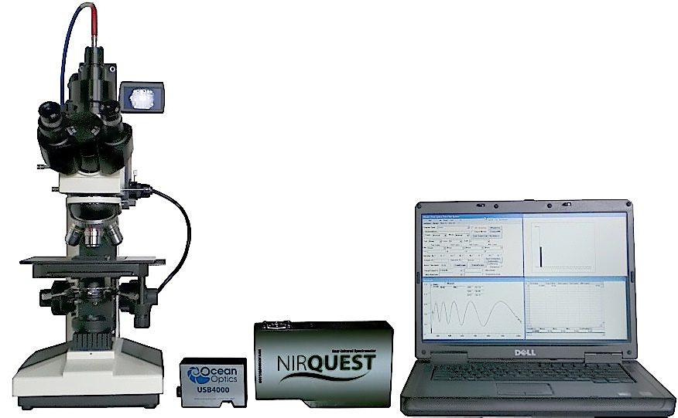
The MP100-ME-VIS-NIR Thin Film Measurement System comes standard with a manual metalllurgical microscope, which is designed to fit your application needs. The MP100-ME-VIS-NIR provides the ability to measure within the wavelength range of 380 nm to 1700 nm for Reflection and Transmission measurements continuously with one scan, the system also measure cell gap on LCD, polyemide on ITO, color filter CIE chromaticity, and color filter thickness. MP100-ME-VIS-NIR is also able to measure Oxide, Nitride, Photoresist and Polysilicon films. The powerful software algorithms can perform single, double, and triple layer thickness calculations. As well as special search and fit routines that quickly converge the algorithm and variables in an accurate thickness measurement tool.

The MP100-ME-VIS-NIR USB spectrometer uses multiple gratings to achieve a wide spectrum range from UV to NIR. The spectrometer bridges the microscope to the notebook computer through a USB cable and Single Fiber Optic Cable. Detaching the Fiber Optic Cable from the microscope attachment can make the system compact and portable if necessary. The unique video display design of the microscope attachment provides the operator with an ergonomic view of the sample area thus eliminating tedious viewing through conventional microscope optics.

The MP100-ME-VIS-NIR user interface is divided into four quadrants that represent measurement, setup parameters, visual spectral display, thickness result bar graph and a thickness result data table. This fully illustrated interface provides instant data return. The main MPO software also operates in conjunction with Microsoft Office™, which allows the operator to save measurement data in MS EXCEL™ format and store it within an MS ACCESS™ database for future reference. This collaboration of software allows you to generate the measurement reports that you need fast and easily.

MP100-ME-VIS-NIR Microspot Thin Film Measurement System

MP100-ME-VIS-NIR Architecture
TV camera with View screen
Visible Spectrometer

NIR Spectrometer
Fiber Optics
Slit
Aperture
Light Source
Objective Lens
Sample
Light Source
Specifications (MP100-ME-VIS-NIR):

Scanning range: 380 nm to 1700 nm, standard
Spectrum resolution: 4 nm
Precision: 0.3 nm
Measuring speed: 5 seconds

Measurement specification:

 |  | 1st Layer |  | 2nd Layer |  | 3rd Layer  0 -10,000Å |  | 4th Layer  0 -10,000Å
Film Type | Objective  Lens | Range | 1σ | Range | 1σ | Range | 1σ | Range | 1σ
P1/P2/ITO/Oxide/Gla | 5x, 10x | 100 - 30,000Å | 5Å | 100 - 10,000Å | 5Å | 100 - 2,000Å | 3Å | 100 - 3,000Å | 3Å
Oxide/Si | 5x, 10x | 200 - 30,000Å | 2Å
 |  | 30,000,- 50,000Å | 5Å
 | 40x,60x | 200 - 10,000Å | 2Å
 |  | 10,000 - 20,000Å | 5Å
Nitride/Si | 5x, 10x | 150 - 20,000Å | 2Å
 | 40x, 60x | 150 - 15,000Å | 2Å
Photoresist/Si | 5x, 10x, 40x | 500 - 20,000Å | 5Å
Nitride/Oxide/Si | 5x, 10x | 150 - 20,000Å | 5Å | 100 - 10,000Å | 5Å
Poly/Oxide/Si | 5x, 10x | 100 - 5,000Å | 5Å | 100 - 10,000Å | 5Å
Oxide/Poly/Oxide/Si | 5x, 10x | 100 - 10,000Å | 5Å | 0 - 10,000Å | 5Å | 0 - 10,000Å | 5Å
Oxide/Al | 5x, 10x, 40x | 2,000 - 20,000Å | 5Å
Photoresist/Cr | 5x, 10x, 40x | 500 - 20,000Å | 5Å
Oxide/NiFe | 5x, 10x, 40x | 2,000 - 20,000Å | 5Å
Photoresist/Glass | 5x, 10x, 40x | 500 - 20,000Å | 10Å
ITO/Oxide/Glass | 5x, 10x, 40x | 100 - 3,000Å | 2Å | 100 - 2,000Å | 2Å
CIE Color measurement | 5x
Very Thick Film | 5x | 50,000-150,000Å | 100Å
Customized film types are available for your applications.

Measuring spot size: 5x Objective is 200 microns, 10x Objective is 100 microns, 20x Objective is 50 microns, 40x Objective is 25 microns.
Viewing options: 2" camcorder screen, and dual microscope eyepiece lenses. Also applies to Transmission mode.

Mission Peak Optics Inc.
46941 Rancho Higuera Road, Fremont, CA 94539 USA
Tel: (510) 438-0384 Fax: (510) 438-9795
Website: www.missionpeakoptics.com Email: sales@missionpeakoptics.com

